EXP NO : 9 Implement a Basic Reinforcement Learning Model (Q-Learning)

AIM : To implement the Q-Learning algorithm using Python and NumPy to learn the optimal path in a reward-based environment by updating the Q-table through repeated training episodes.

ALGORITHM :
- Start the program.
- Import the NumPy library.
- Define the reward matrix R to represent the rewards for moving between states.
- Initialize the Q-table Q with zeros.
- Set the discount factor gamma = 0.8 and the number of training episodes to 1000.
- Start each episode from a randomly selected state.
- Repeat until the goal state (state 5) is reached:
- Identify the valid actions from the current state.
- Randomly select one valid action.
- Determine the next state based on the selected action.
- Update the Q-table using the reward and the maximum Q-value of the next state.
- Repeat the training process for all 1000 episodes.
- Display the final Q-table.
- Stop the program.
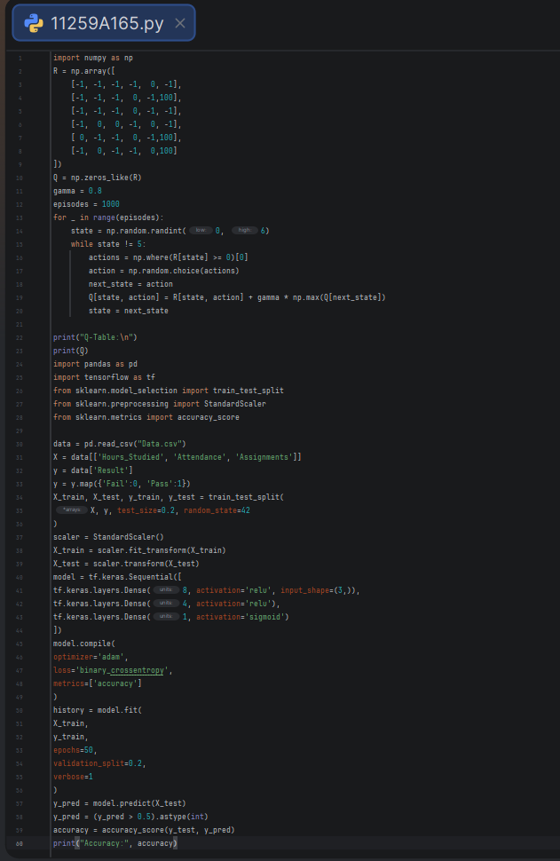
PROGRAM :

OUTPUT :

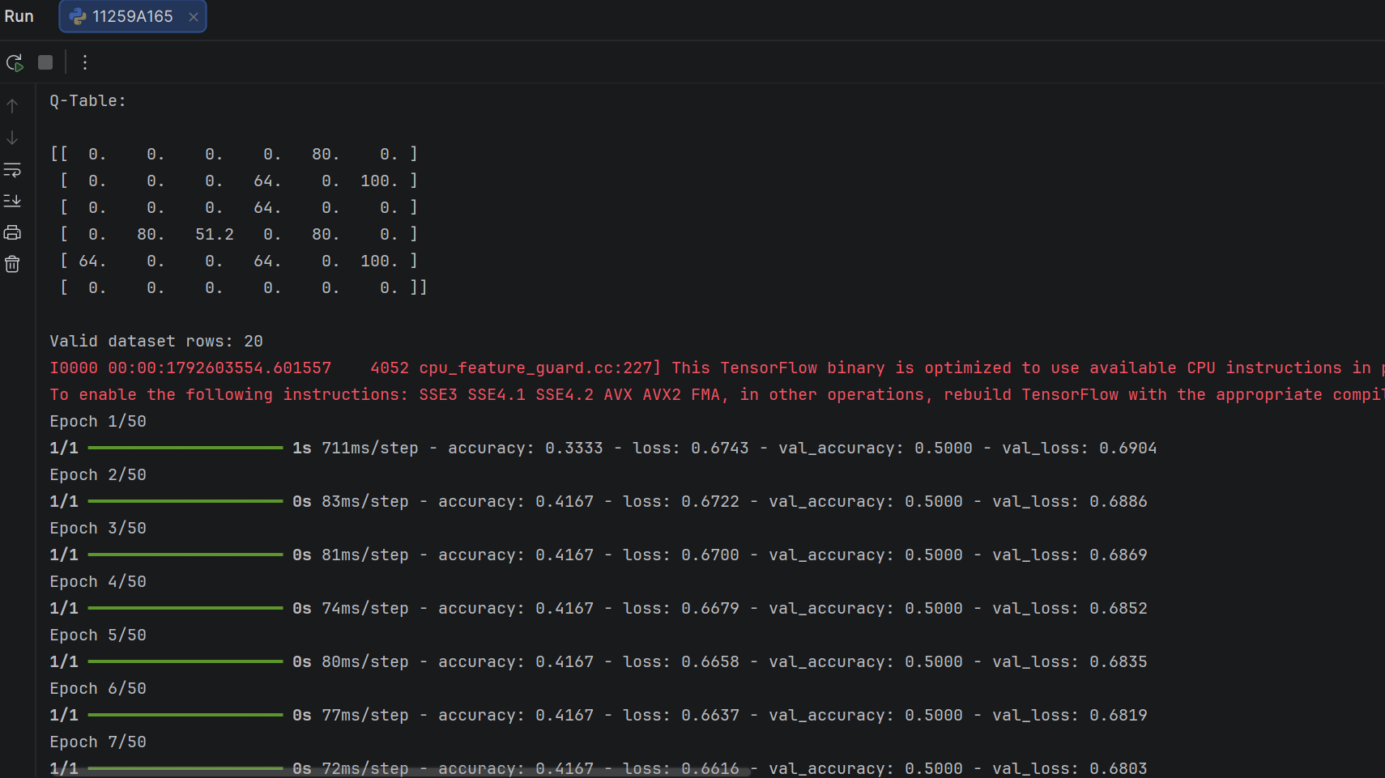
RESULT : Thus, the Artificial Neural Network was implemented successfully using TensorFlow and Keras to predict whether students would pass or fail based on their study hours, attendance, and assignments. The model was trained for 50 epochs, and its prediction accuracy on the testing dataset was calculated and displayed.

